MAT 050 – What’s in this folder? from Tracy White, Rifle Campus, twhite@coloradomtn.edu

This folder is meant to provide a starting point for someone who has not taught MAT 050. It is a folder of resources which you may or may not want to use. The major requirement is that all MAT 050 instructors cover all of the new state competencies that are listed for the class, but how you choose to do it is up to you. These resources are meant to be helpful options, not requirements.

The suggested text is:

Developmental Mathematics (8th Edition) [Paperback]
Marvin L. Bittinger,

Judith A Beecher, Publication Date: January 6, 2011
ISBN-10: 0321731530 | ISBN-13: 978-0321731531
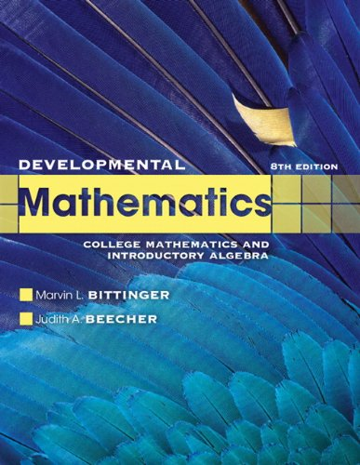

A useful supplemental text (for you as the instructor, not necessarily for your students to purchase) is:
Math Study Skills Workbook 4th edition [Paperback], Paul D. Nolting
Publication Date: January 1, 2011 | ISBN-10: 0840053096 | ISBN-13: 978-0840053091
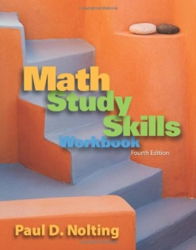

A helpful text to place “on reserve” in your Learning Lab for students to review prereq material is:
Basic College Mathematics: An Applied Approach, 8th, 9th, or 10th Edition
Richard N. Aufmann Palomar College, Joanne S. Lockwood Nashua Community College
For the 10th edition: ISBN-10: 1133365442, ISBN-13: 9781133365440
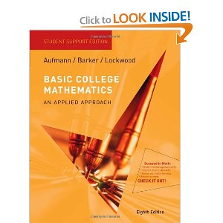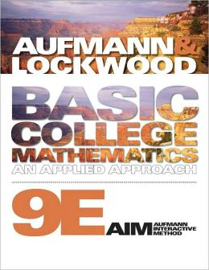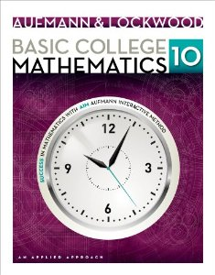
In this folder you will find the following files:

- Competencies Comparison: MAT 050 is mostly a combination of MAT 060 and MAT 090, with a couple things added and some things thrown out. This is a competencies comparison that lists out the similarities and differences between the new class and the two old classes.
- MAT 060 competencies, MAT 090 competencies: These are the lists of competencies from MAT 060 & MAT 090, where the material used in MAT 050 is highlighted. This might be helpful if you’ve taught MAT 060 or MAT 090, to get a better idea of what is covered in MAT 050.
- MAT 050, Objectives: This is a list of the objectives/competencies from MAT 050, with book sections from the suggested text that cover each section as well as video links that students can use for additional help or that an instructor can use for a “flipped” classroom.
- Schedule – Fall, Spring: Sample schedules/timelines, using the suggested text. There is also a possible breakdown for time spent on each topic, whether using this text or another.
- Prereq Review with workspace: The prereq review assignment, with workspace for students to complete the problems. You can choose to have students work on this in groups day 1 and finish on their own to turn in.
- Prereq Review Solutions: Please let me know if you find errors.
- Prereq Material: This includes the same Prereq Review that is also included in this folder, but without the workspace. It also includes book sections and video links that address the prerequisite material that is required to be successful in this course for students to use on their own to review as needed.
- Compound Inequalities Explanation: A section from a textbook that covers compound inequalities, a topic not covered by the suggested text. The link to this material is: https://www.tcc.fl.edu/Current/Academics/LearningCommons/First%20Floor%20Documents/17SolvingLinearInequalitiesAndCompoundInequalities.pdf
- Compound Inequalities HW: A set of HW problems for this material.
- Compound Inequalities Solutions: A folder of images for color solutions. If you open the Image file and click on the arrows, it will take you through all of the pages. Please let me know if you find errors.
- Compound Inequalities Solutions: A single pdf file of the solutions in black & white.
- Math Study Skills: Two powerpoint presentations that I found on the internet that seem like they do a reasonable job of discussing this important topic.
- Memletics Learning Style Inventory: A pencil & paper learning style inventory that students can complete to help them understand how they best learn. It also could be a great math assignment, b/c it involves answering questions about how you learn, tallying up results, graphing and interpreting results on Memletics’ own graph – a great practical application!
- Dream Job/Dream House: A sample assignment that uses percents and formulas in a real-world, hopefully relevant, way.
- Lines Ideas from AMATYC: A journal article from the MathAMATYC Educator that includes some ideas for creating more real-world applications of linear equations in two variables. The ideas in here may be used as is or may inspire some additional assignment ideas. Please share any great ideas that you come up with!

